**ASSIGNMENT 11**

Ria Mittal

322010

T.E. B - B1

EXAMPLE 1:

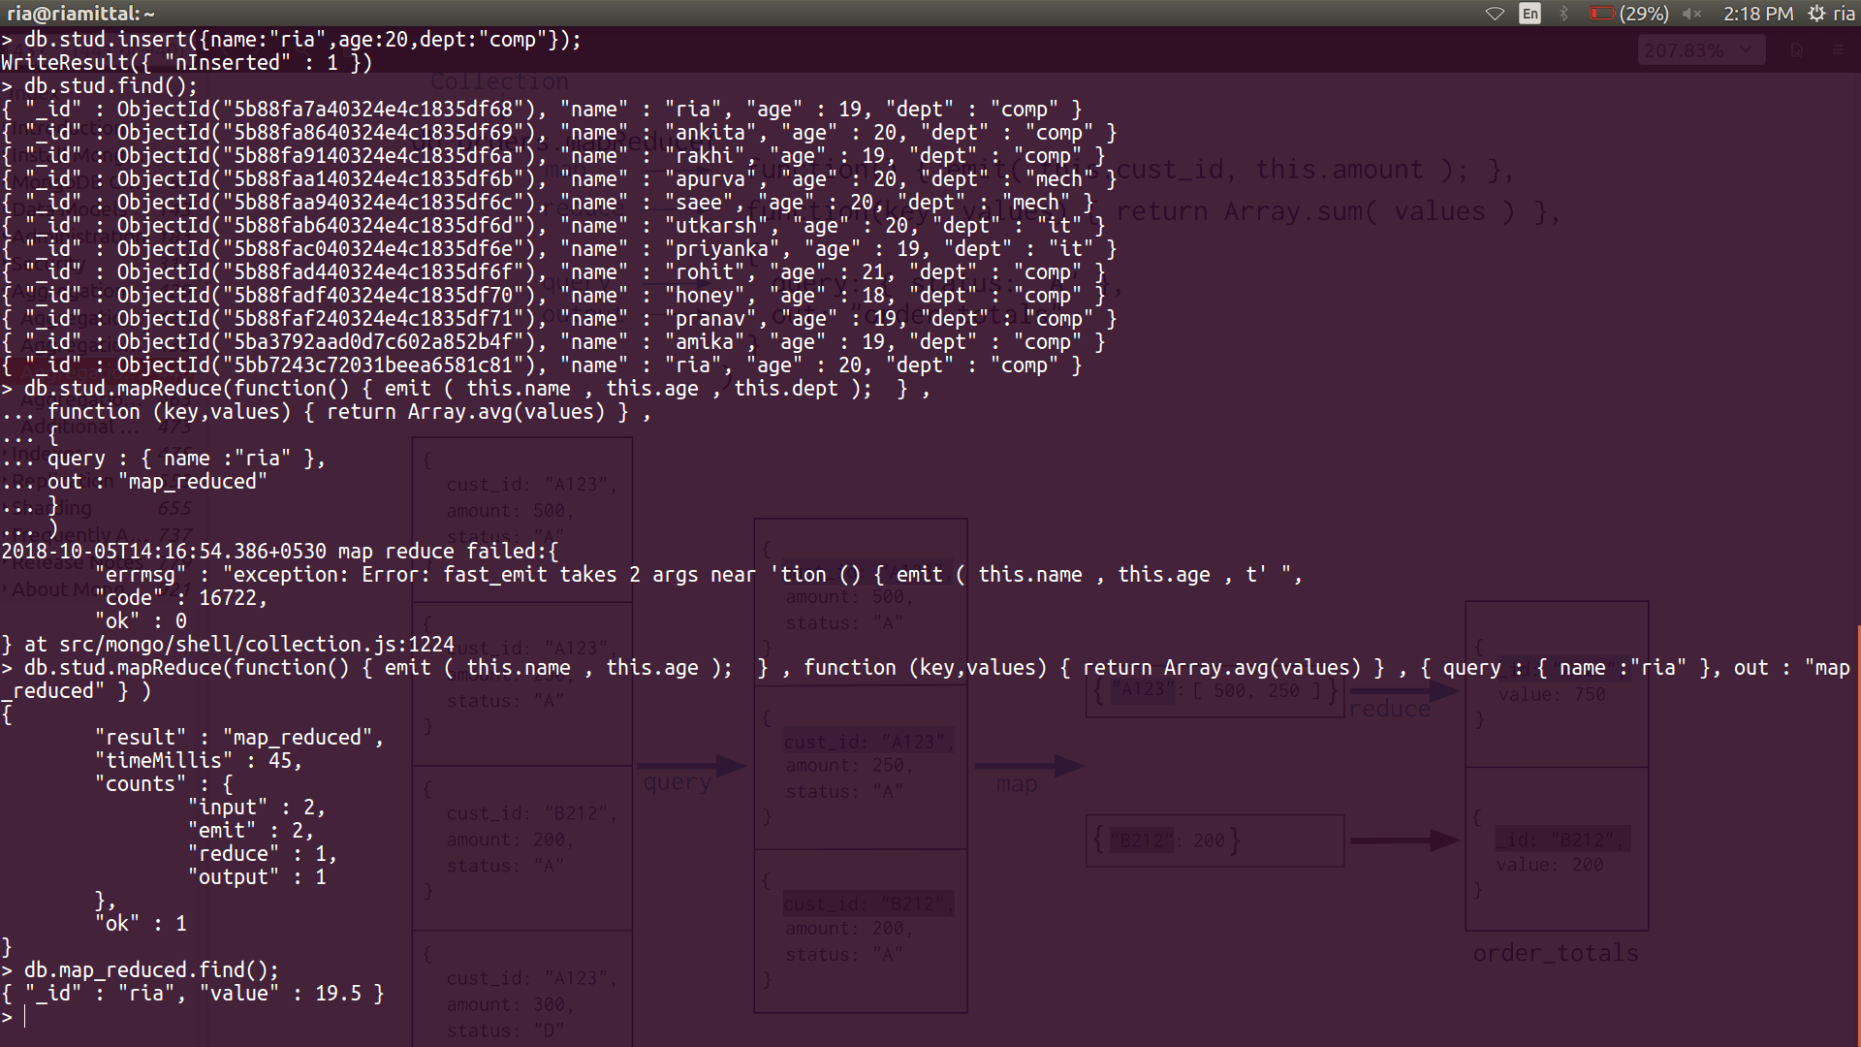

EXAMPLE 2:

